**HOMEWORK 6**

**Họ và tên: Nguyễn Huỳnh Trúc Thanh**

**MSSV: N20DCCN142**

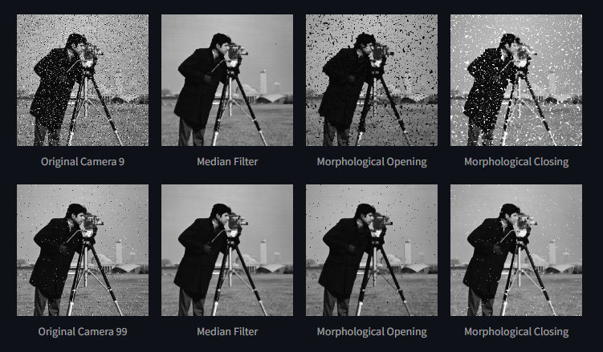

**Link github:** [**https://github.com/NHT2-gh/Image_Processing.git**](https://github.com/NHT2-gh/Image_Processing.git)